**SOFTWARE DESIGN DOCUMENT**

**for**

**E-SYLLABUS**



**Yunus Tufan Bozkurt**

**Hazal Öykü Şen**

**Merve Nur Telli**

**Özge Tula**

**Table Of Contents**

**1. Introduction** 3

1.1. Purpose 3

1.2. Scope 3

**2.System Overwiev** 3

2.1.Flowchart 3

**3.Desing Viewpoints** 4

3.1.Context Viewpoint 4

3.2.Logical Viewpoint 6

3.3.Interface Viewpoint 7

3.3.1.User Interface…………………………………………………………………………………………………………………………………….7

3.4.Interaction Viewpoints…………………………………………………………………………………………………………………………….9

3.5.Database Viewpoints………………………………………………………………………………………………………………………….….11

**Table Of Figure**

Figure 1. Flowchart……………………………………………………………………………………………………………………………………….…...3

Figure 2. Use Case Diagram………………………………………………………………………………………………………………………………..4

Figure 3. View Syllabus Use Case Diagram………………………………………………………………………………………………………….4

Figure 4. Import Use Case Diagram…………………………………………………………………………………………………………………….5

Figure 5. Edit Use Case Diagram………………………………………………………………………………………………………………………...5

Figure 6. Create Use Case Diagram………………………………………………………………………………………………………………….…5

Figure 7. Export Use Case Diagram…………………………………………………………………………………………………………………….6

Figure 8. Class Diagram………………………………………………………………………………………………………………………………………6

Figure 9. Login Page……………………………………………………………………………………………………………………………………..……7

Figure 10. Language Choosing……………………………………………………………………………………………………………………………7

Figure 11. Entering the Course Code………………………………………………………………………………………………………………….7

Figure 12. Importing Syllabus…………………………………………………………………………………………………………………………….7

Figure 13. Editing Syllabus…………………………………………………………………………………………………………………………………7

Figure 14. Editing Course Objectives………………………………………………………………………………………………………………...7

Figure 15. Exporting Syllabus…………………………………………………………………………………………………………………………….8

Figure 16. Confirmation Window…………………………………………………………………………………………………………………..….8

Figure 17. Creating New Syllabus………………………………………………………………………………………………………………………8

Figure 18. Filling Empty Sections……………………………………………………………………………………………………………………….8

Figure 19. After filling in the blank section………………………………………………………………………………………………………..8

Figure 20. Create Sequence Diagram…………………………………………………………………………………………………………………9

Figure 21. Edit Sequence Diagram……………………………………………………………………………………………………………………..9

Figure 22. Import Sequence Diagram……………………………………………………………………………………………………………….10

Figure 23. Export Sequence Diagram…………..…………………………………………………………………………………………………..10

Figure 24. Database Diagram………………………………………………………………….……………………………………………………….11

**1.INTRODUCTION**

* 1. **PURPOSE:**

This Software Design Document (SDD) describes the detailed structure of the components of the e-syllabus. This includes the architectural features of the system down through details of what operations each code module will perform and the database layout.

* 1. **SCOPE:**

Our program is a computer application which helps lecturers to create, export, import and edit syllabus with both English and Turkish language support. The program based on a relational database with school web site and application. The data which given by user held in a database for every use of that data.

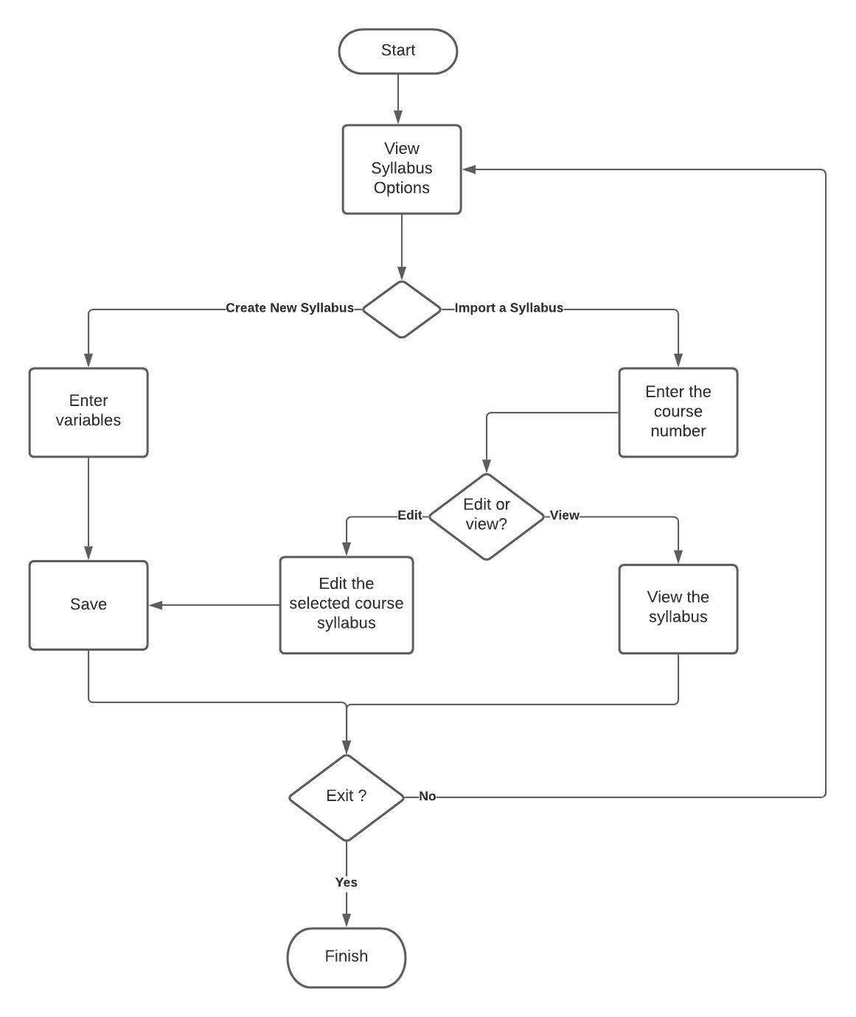 **2.SYSTEM OVERVIEW**

**2.1 FLOWCHART:**

Figure 1:Flowchart

**3.DESIGN VIEWPOINTS**

**3.1.Context Viewpoint**

There is only one kind of user in our system. The system supplies four services to them,

namely view, import, export and edit syllabus.

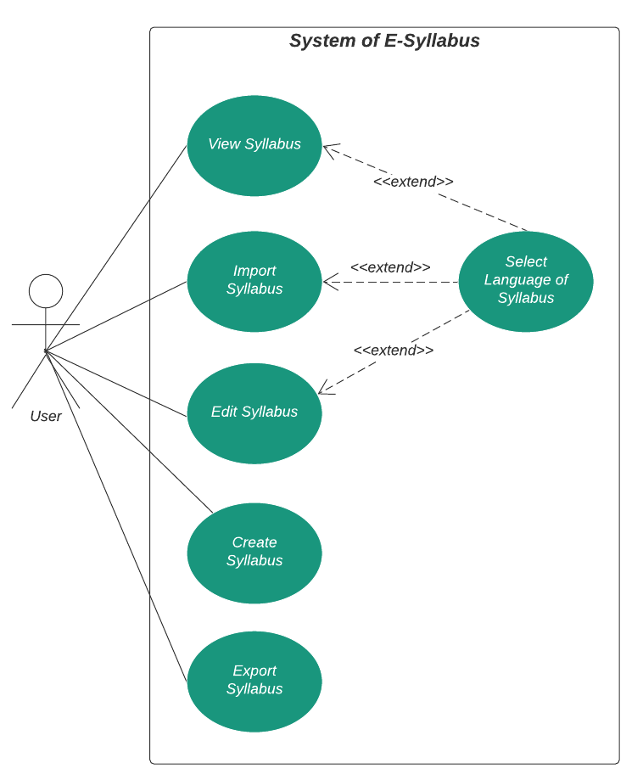

Figure 2: Use Case Diagram

**3.1.1. View Syllabus**

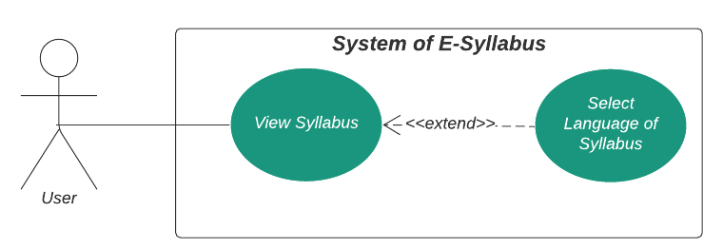The user can view the curriculum of the course they want by selecting their language.

Figure 3: View Syllabus Use Case

**3.1.2. Import Syllabus**

The users can import the curriculum of the course them wants to the application by choosing language.

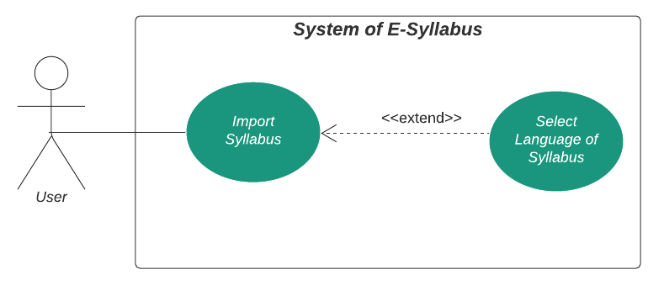

Figure 4: Import Syllabus Use Case

**3.1.3.Edit Syllabus**

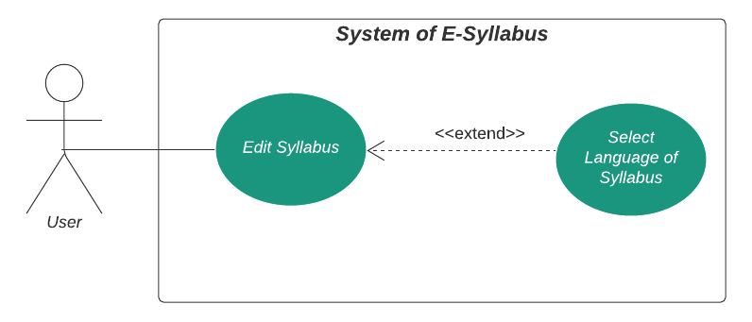Users can make changes in the curriculum table on the course they transfer by choosing the language.

Figure 5: Edit Syllabus Use Case

**3.1.4.Create Syllabus**

Users can create a new syllabus from scratch.

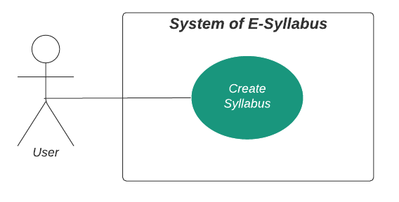

Figure 6: Create Syllabus Use Case

**3.1.5.Export Syllabus**

Users can export syllabus created from scratch or edited.

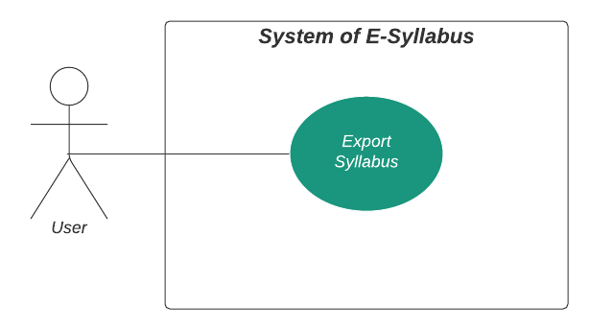

Figure 7: Export Syllabus Use Case

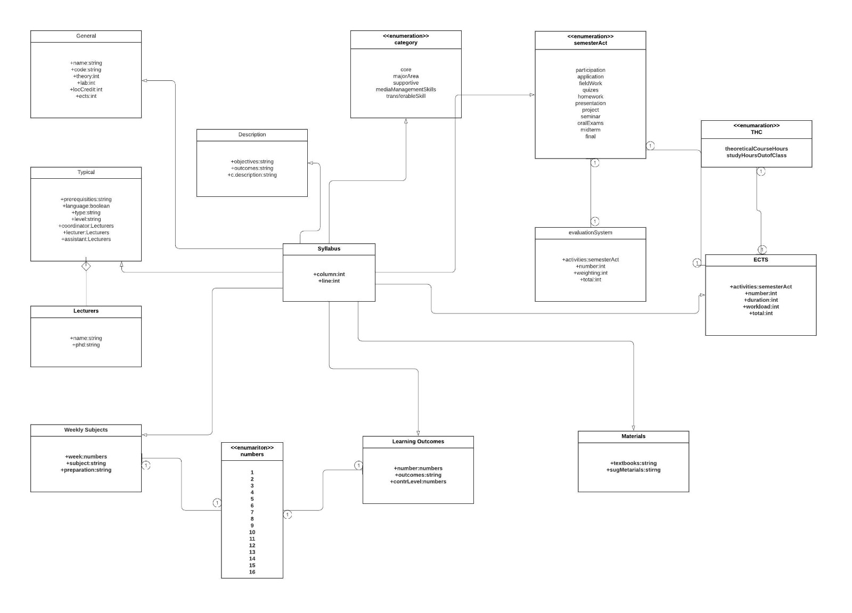**3.2.Logical Viewpoint**

Figure 8:Class Diagram

**3.3.Interface ViewPoint**

**3.3.1.User Interface**

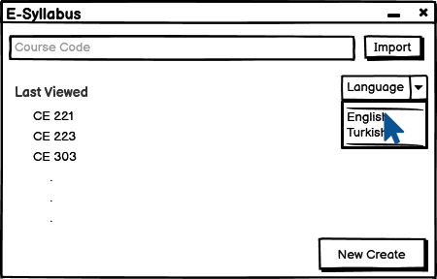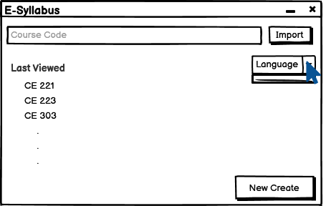

Figure 10: Language Choosing

Figure 9: Login page

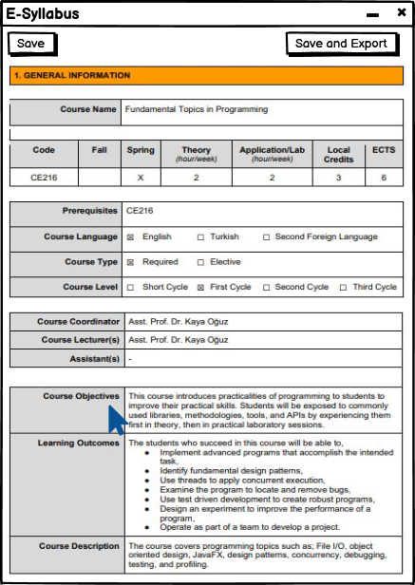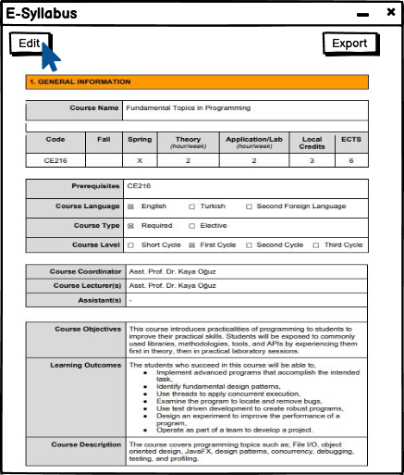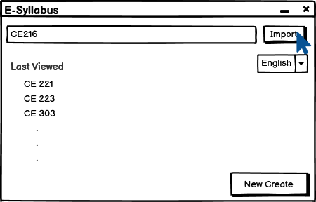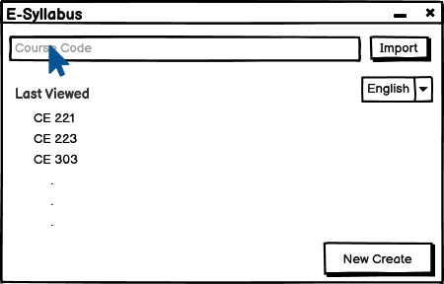

Figure 14: Editing Course Objectives

Figure 13: Editing syllabus

Figure 12: Importing syllabus

Figure 11: Entering the course code

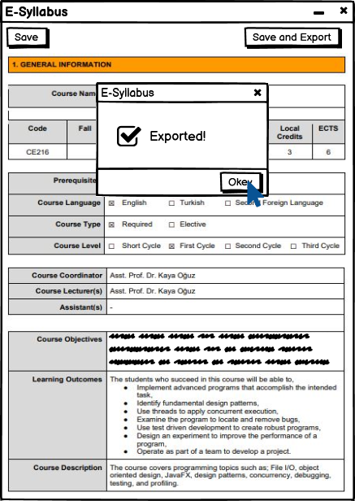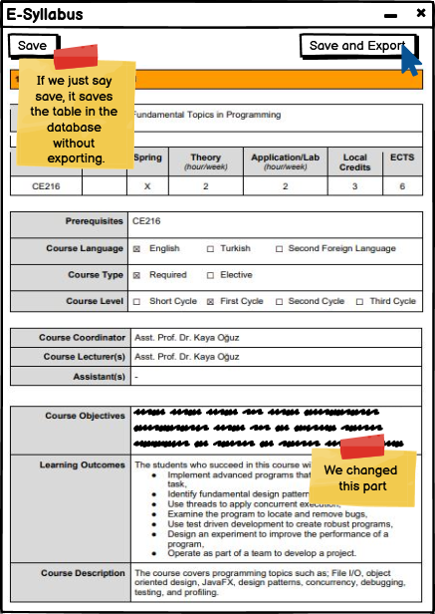

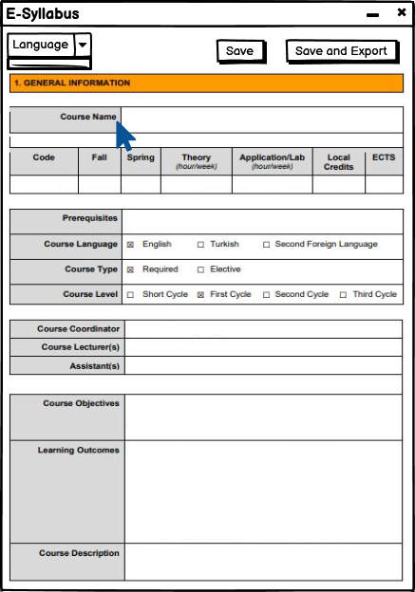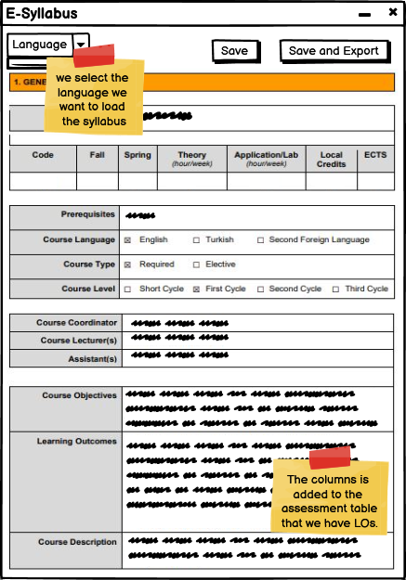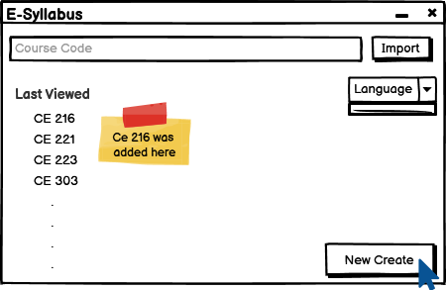

Figure 19: After filling in the blank sections, choosing a language and save or export.

Figure 18: Filling empty sections

Figure 17: Creating new syllabus

Figure 15: Exporting Syllabus

Figure 16: Confirmation window

**3.4.Interaction Viewpoints**

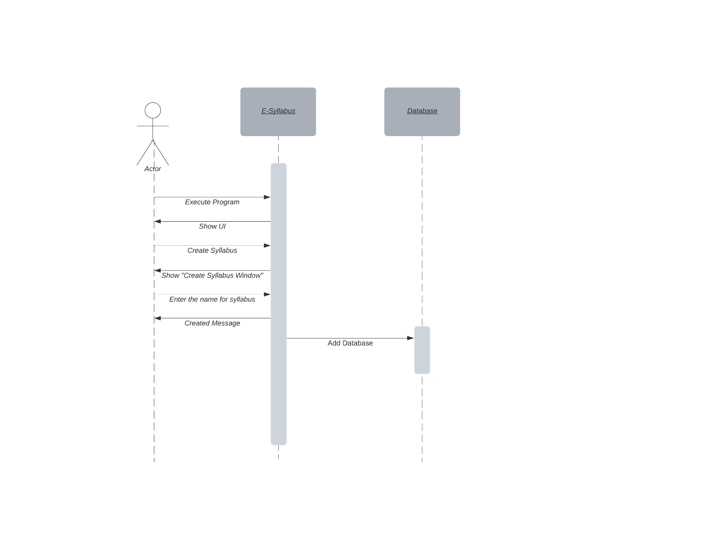

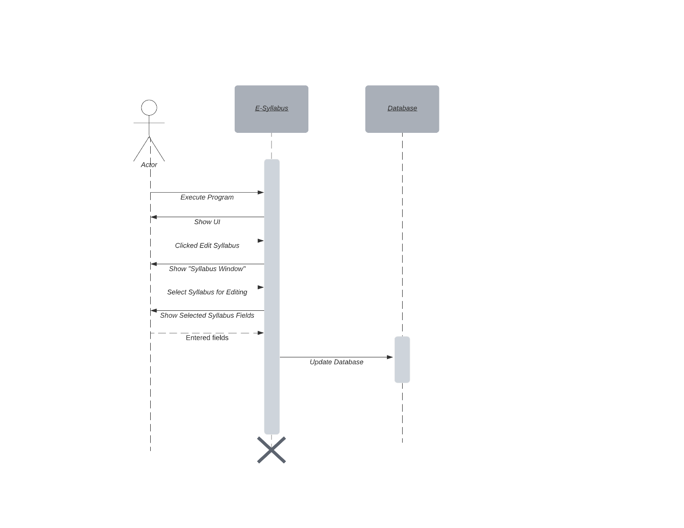

Figure 21: Edit Sequence Diagram

Figure 20: Create Sequence Diagram

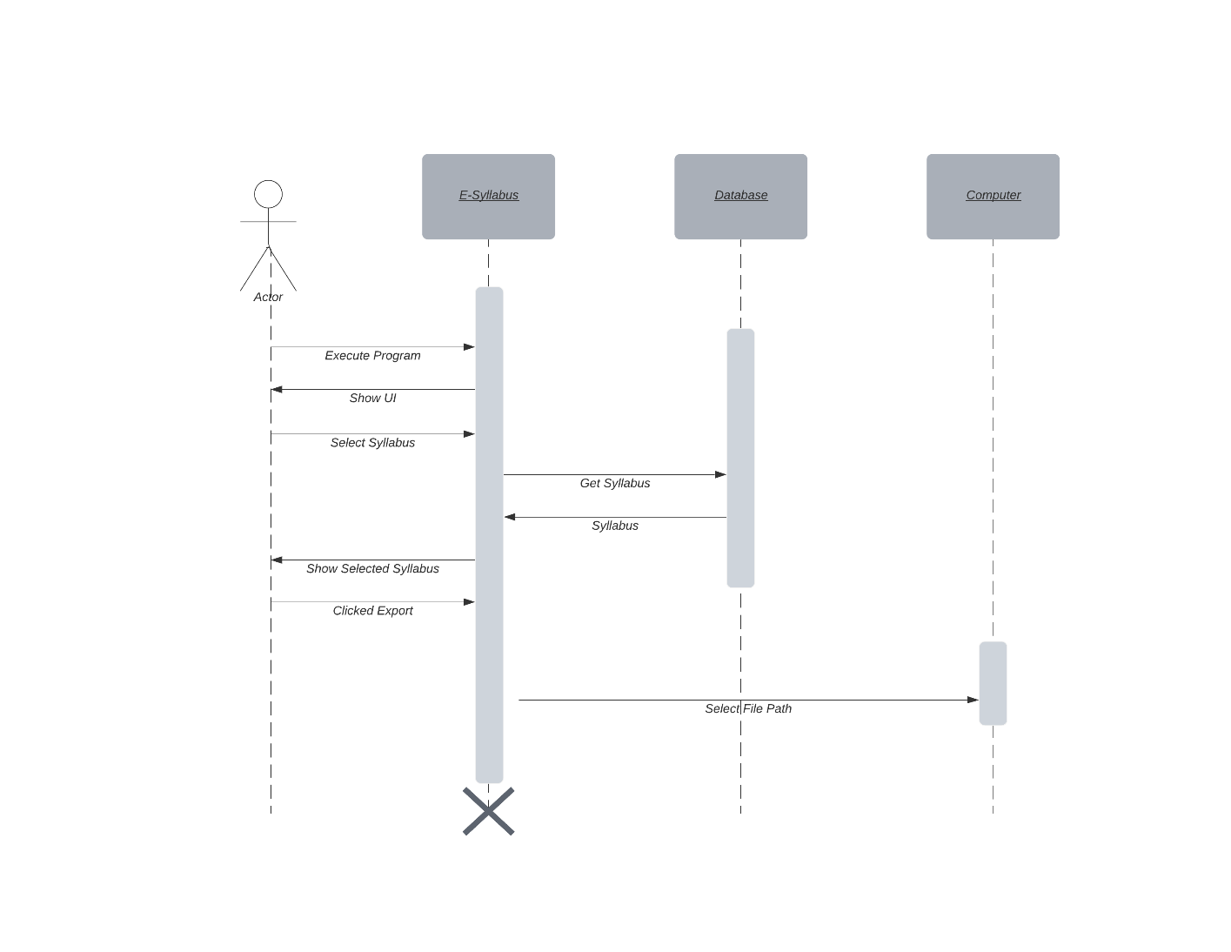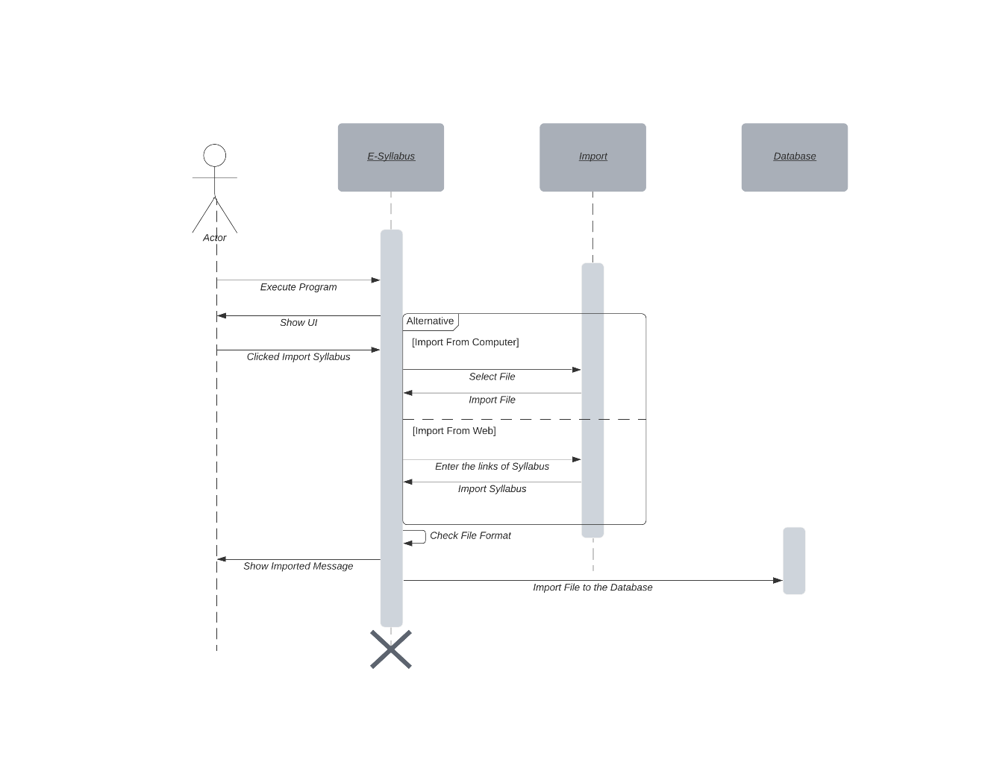

Figure 23: Export Sequence Diagram

Figure 22: Import Sequence Diagram

**3.5.Database Viewpoint**

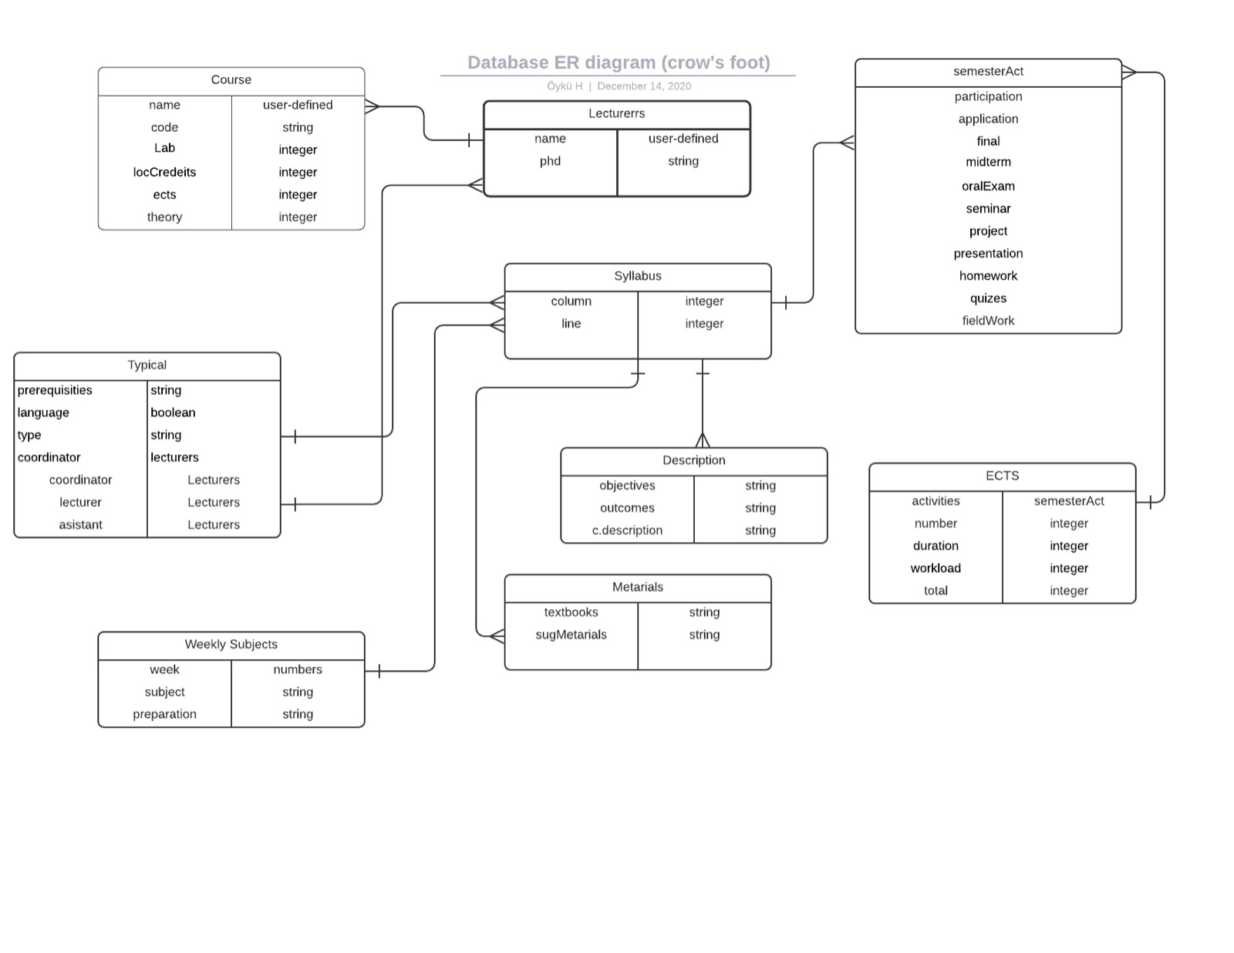

Figure 24: Database Diagram